N5 Maths Prelim Revision Booklet

Revise Your Notes $→$Practise Topic-by-Topic Questions$→$Practise Mixed Questions

Formula Sheet
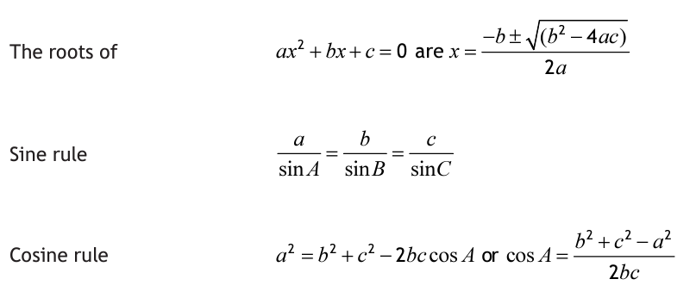

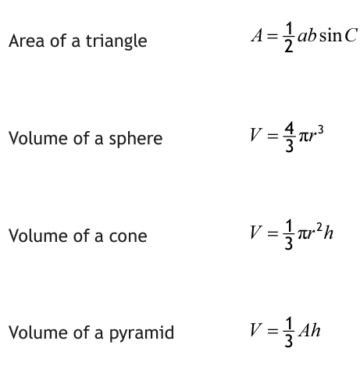
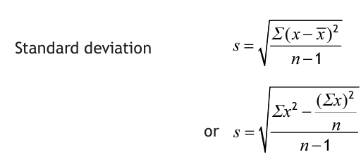
Topic | Notes
Volume
Equations/Inequations
Circle Geometry
Scientific Notation
Expanding Brackets
Similar Shapes
Percentages
Numerical Fractions
Pythagoras
Straight Lines
Functions
Factorising
Statistics
Quadratics
Arcs and Sectors
Changing the Subject
Surds
Indices
Trigonometric Graphs
Simultaneous Equations
Area, Sine and Cosine Rules
Algebraic Fractions
Volume (Calculator)
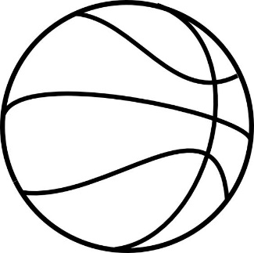
- A basketball is produced in the shape of a sphere with a diameter of 24.2 centimetres.

24.2 cm
Calculate the volume of the basketball.
Give your answer correct to 2 significant figures.
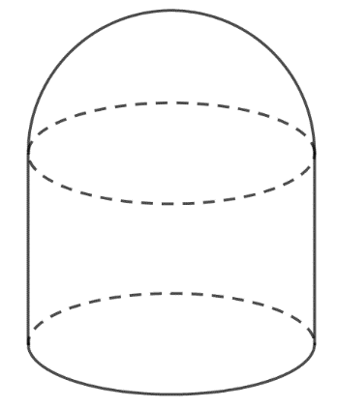
- A voice-activated speaker is in the shape of a cylinder with a hemisphere on top, as shown in the diagram.
The speaker has:
22 cm
- height 22 centimetres
- diameter 16 centimetres
Calculate the volume of the speaker.
Give your answer correct to 2 significant figures.
16 cm

- A cone is shown in the diagram below.
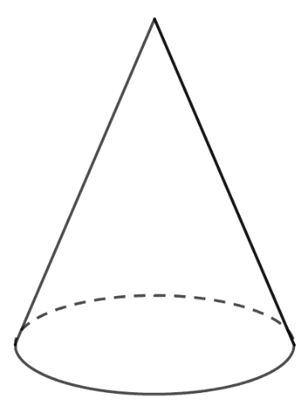

13 cm

The height of the cone is 13 centimetres.
The volume is 340 cubic centimetres.
Calculate the diameter of the cone.
Give your answer correct to 1 decimal place.
Equations and Inequations (Non-calculator)
- Solve, algebraically, the inequation:
$$4+x>3\left(2x-1\right)-8$$

- Solve the inequation:
$$6\left(1+x\right)<12-2(x-3)$$

- Solve the equation:
$$\frac{2x+3}{4}+1=5$$

- Solve the equation:
$$4+\frac{9}{x}=7$$

- The diagrams below show a rectangle and an equilateral triangle.
All measurements are in centimetres.

$$x$$

$$3x-1$$
$$2x+2$$

Given that the perimeter of the rectangle is equal to the perimeter of the triangle, determine algebraically the length of each side of the triangle.

Circle Geometry (Non-calculator)
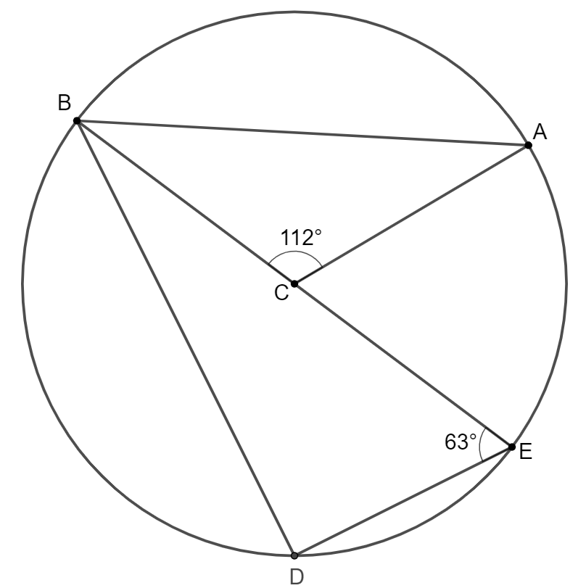
- The diagram shows a circle
with centre $C$.
$BE$ is a diameter of the circle.
Angle $ACB$ is $112°$.
Angle $DEB$ is $63°$.
Calculate the size of angle $ABD$.

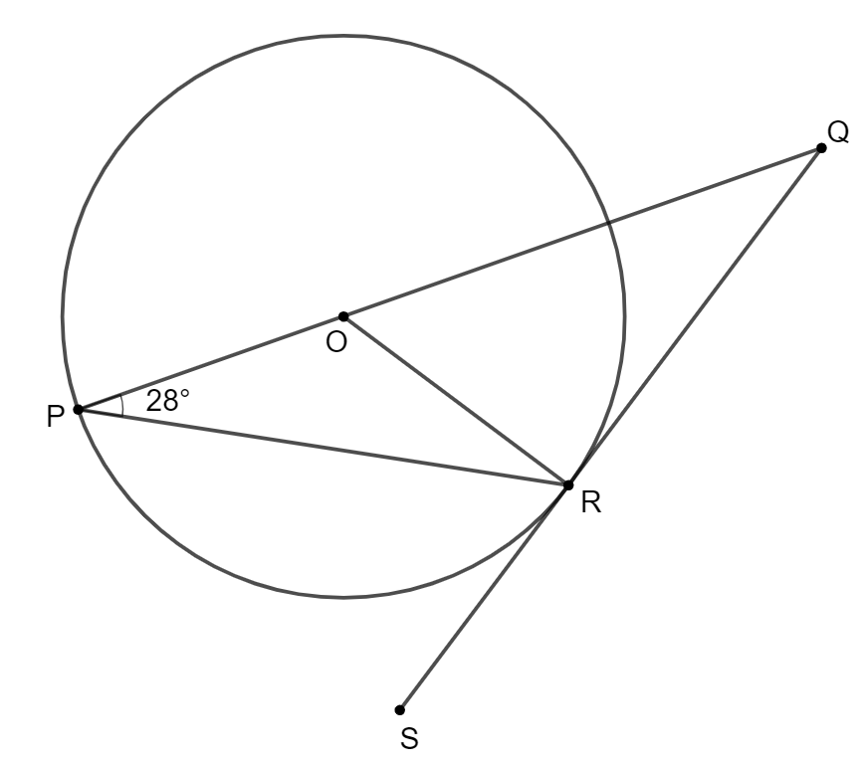
- The diagram shows a circle with centre $O$.
$QS$ is a tangent to the circle at the point $R$.
$PQ$ is a straight line.
Angle $QPR$ is $28°$.
Calculate the size of angle $PQR$.

Scientific Notation (Calculator)
- In one particular year, it was determined that in the UK cars were driven for a total distance of approximately $3.23×{10}^{11}$ miles.
It was determined that $27\%$ of that distance covered was on motorways.
Calculate the distance that was covered on motorways.
Give your answer in scientific notation, correct to 3 significant figures.

- The mass of the Earth is $5.94×{10}^{24}$ kilograms.
The mass of the planet Mercury is $3.30×{10}^{23}$ kilograms.
Calculate how many times as heavy as Mercury the Earth is.

Expanding Brackets (Non-calculator)

- Expand and simplify:
$$\left(3x-1\right)\left(2x+3\right)-2x$$
- Expand and simplify:
$$(x+5)(x^{2}-3x+2)$$
- Expand and simplify:
$$(x-4)(2x^{2}+3x-1)$$
- Expand and simplify:
$$x\left(x-3\right)-(x-3)(x+1)$$

- Expand and simplify:
$${\left(x+2\right)}^{3}$$
Similar Shapes (Calculator or non-calculator)
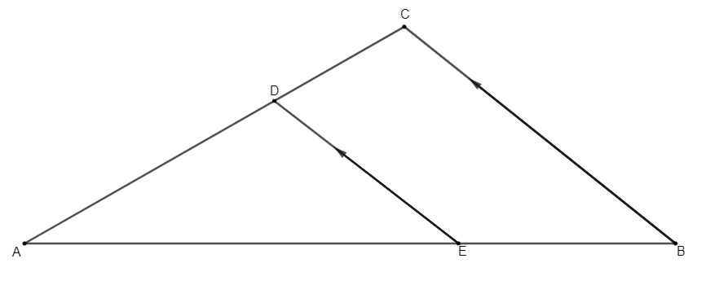
- In the diagram below:
5 cm
8 cm
- $ED$ and $BC$ are parallel.
- $DE$ = 5 centimetres
- $CB$ = 8 centimetres
- $AE$ = 10 centimetres

10 cm
$x$ cm
The length of $EB$ is $x$ centimetres.
Calculate the value of $x$.

- A chef has two sizes of cylindrical cake tins, which are mathematically similar.

6 cm
15 cm

The smaller cake tin has a height of 6 centimetres, and the larger has a height of 15 centimetres. The smaller cake tin has a volume of 480 cubic centimetres. Calculate the volume of the larger cake tin.

- The two sizes of prints of a painting shown below are mathematically similar.
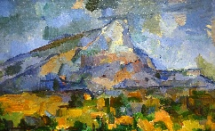
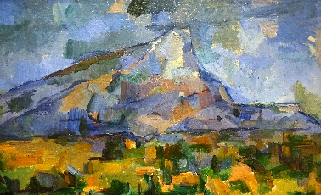
21 cm
35 cm

If the cost of each print is proportional to its area, and the larger print costs £40, determine the cost of the smaller print.
Percentages (Calculator)
- A savings account pays 2.5% interest each year on any savings.
Alex deposits £320 in the savings account.
Calculate the value of Alex’s savings in 3 years’ time.

- The value of a property was valued to be £138 000 at the end of 2023.
It is expected to appreciate by 1.7% each year.
Calculate the expected value of the property at the end of 2027.
Give your answer correct to three significant figures.

- After a 4% pay rise, Sam is paid £11.18 per hour.
Calculate how much Sam was paid per hour before the pay rise.
- During the week of Pancake Day, a fruit shop sold 56 lemons.
This was 75% more than the number sold in an average week.
Calculate how many lemons the shop sells in an average week.

- (Non-calculator). For a particular match, St Mirren’s stadium was only 60% full, and its attendance on that day was 4,800. Determine the number of spectators that the stadium could hold when full.
Numerical Fractions (Non-calculator)
- Calculate:
$$2\frac{3}{5}×\frac{10}{11}$$
- Calculate:
$$5\frac{1}{3}÷2\frac{2}{5}$$
- Calculate:
$$2\frac{5}{6}+3\frac{3}{5}$$
- Calculate:
$$\frac{3}{4} of \left(4-1\frac{1}{2}\right)$$
Pythagoras (Calculator)
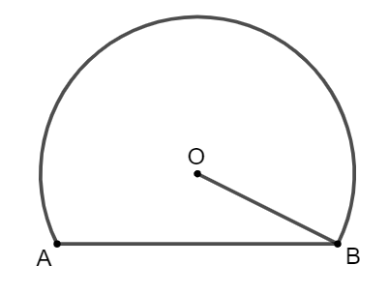
- The cross-section of a digital pen is in the shape of a circle, with one part made to be flat as shown in the diagram below:
The centre of the circle is $O$.
The chord $AB$ is 8 millimetres.
The radius $OB$ is 4.5 millimetres.
Calculate the height of the pen when it is laid flat on a desk.
4.5 mm
8 mm
height
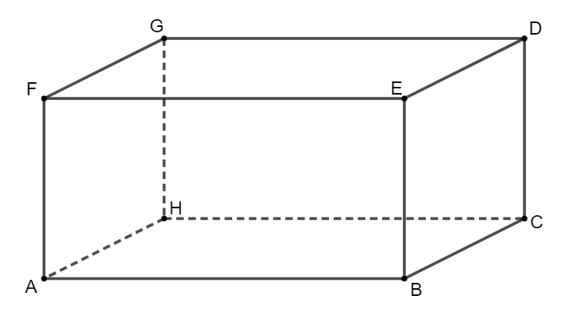
- A room is in the shape of a cuboid, as shown in the diagram below:
$AB$ is 6 metres.
$BC$ is 5 metres.
$CD$ is 3 metres.
Calculate the distance $AD$.
3 m
5 m
6 m

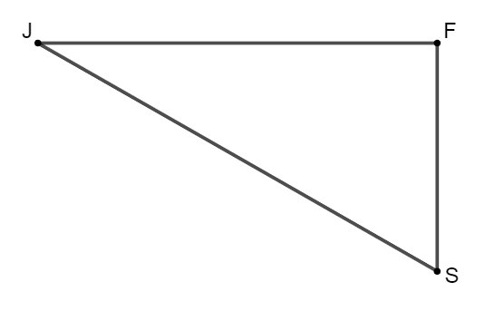
- A dinghy race begins by sailing directly East for 3.5 km, from the Jetty (J) to the First Buoy (F). The dinghies then sail 1.8 km to the Second Buoy (S). They then sail 4.1 km back to the Jetty. A sketch of the course is below:
Determine whether the Second Buoy is directly South of the First Buoy.
4.1 km
3.5 km
1.8 km
Straight Lines (Non-calculator)
- Find the equation of the line passing through the points $\left(-3,2\right)$ and $(1,10)$.
- Find the equation of the line passing through the points $\left(4,5\right)$ and $(8,-1)$.
Give the equation in its simplest form.
- A straight line has equation $4x+3y-6=0$.
Find the coordinates of the point where this line crosses the $y$-axis.

- A straight line has equation $3x-2y+5=0$.
Find the gradient of this line.

- The Scottish Wildlife Trust records the heights and weights of some red squirrels living in local woodland. The scattergraph below shows the relationship between the height, $H$, and the weight, $W$, of the squirrels.
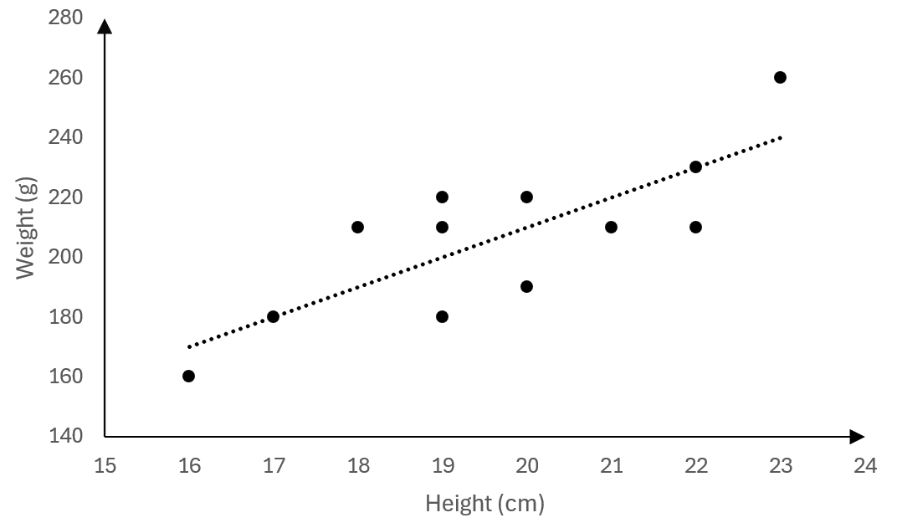
$$Q$$
$$P$$
$$W$$
$$H$$
A line of best fit is drawn.
Point $P$ represents a 17 centimetre tall squirrel which weighs 180 grams.
Point $Q$ represents a 22 centimetre tall squirrel which weighs 230 grams.
a) Find the equation of the line of best fit in terms of $H$ and $W$.
b) Use the equation to estimate the weight of a 24 centimetre tall squirrel.
Functions (Non-calculator)
- Given that $f\left(x\right)=3x^{2}-7$, evaluate $f(-5)$.

- Given that $g\left(x\right)=5x-x^{3}$, evaluate $g(-2)$.

- A function is defined as $f\left(x\right)=3x-4$.
Given that $f\left(a\right)=17$, calculate $a$.

- A function is defined as $g\left(x\right)=2-6x$.
Given that $g\left(t\right)=10$, determine the value of $t$.

Factorising (Non-calculator)
- Factorise fully:
$$2x^{2}-18$$

- Factorise:
$$9m^{2}-25$$

- Factorise:
$$x^{2}-6x+8$$

- Factorise:
$$y^{2}+y-20$$

- Factorise fully:
$$3x^{2}+6x-9$$

- Factorise:
$$2x^{2}-11x+5$$

- Factorise:
$$6x^{2}-13x-5$$

Statistics (Calculator)
- A PC Gaming forum conducted a survey of the ages of its members.
A sample of eleven members’ ages, in years, are shown below:
25 17 21 34 14 18 48 13 32 22 16
a) Calculate the median and interquartile range of the ages of the forum members for this sample.
A Console Gaming forum also conducted a survey of the ages of its members. The median age was 17 years, and the interquartile range was 6 years.
b) Make two valid comments comparing the ages of the members of the PC Gaming forum and the ages of the members of the Console Gaming forum.

- A rural school records the number of miles driven to work each morning by a random sample of eight teachers. The results are below:
16 9 26 3 10 31 25 16
a) Calculate the mean and standard deviation of the number of miles driven to work each morning by its teachers.
A city centre school records the number of miles driven to work each morning by a sample of its teachers.
The mean is calculated to be 6 miles, and the standard deviation is 1.7 miles.
b) Make two valid comments comparing the number of miles driven to work each morning by the teachers at the rural school, and the number of miles driven by the city centre school.

Quadratics (Non-calculator)

- Solve the quadratic equation:
$$x^{2}-3x-10=0$$
- Solve the equation $x^{2}-2x-15=0$.
- Solve $2x^{2}-5x=3$
Arcs and Sectors (Calculator)

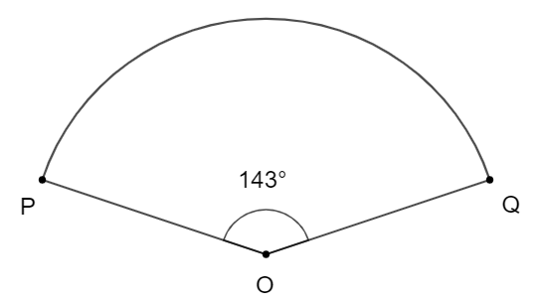
- The diagram below shows a sector of a circle, centre $O$.
The radius of the circle is 24 centimetres.
Calculate the length of the minor arc $PQ$.
24 cm

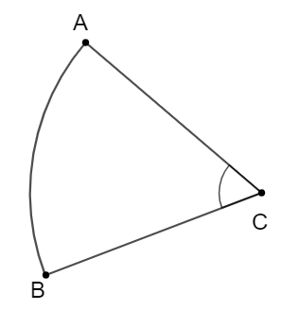
- The diagram below shows a sector of a circle, centre $C$.
The radius of the circle is 14 centimetres.
The area of sector $ABC$ is 104 square centimetres.
Calculate the size of angle $x°$.
$$x°$$
14 cm

Changing the Subject (Non-calculator)
- Change the subject of the formula $P=$ $\frac{2r-k}{3}$ to $r$.

- Change the subject of the formula $t=\sqrt{m-a^{2}}$ to $m$.

- Change the subject of the formula $pr=y-\sqrt{k}$ to $k$.
Surds (Non-calculator)
- Simplify $\sqrt{300}+\sqrt{27}-2\sqrt{3}$

- Simplify $3\sqrt{50}-\sqrt{8}+\sqrt{72}$

- Express $\frac{3\sqrt{5}}{\sqrt{7}}$ with a rational denominator, in its simplest form.

- Express $\frac{4}{\sqrt{12}}$ with a rational denominator, in its simplest form.

- Expand and simplify $\sqrt{6}\left(\sqrt{2}-\sqrt{6}\right)$
Indices (Non-calculator)

- Simplify $\frac{4x^{-1}×3x^{7}}{2x^{4}}$

- Simplify $\frac{{8x}^{3}}{x^{4}×2x}$. Give your answer with a positive power.

- Simplify $p^{3}×{\left(p^{-2}\right)}^{4}$. Give your answer with a positive power.

- Remove the brackets and simplify ${\left(\frac{3}{4}y^{5}\right)}^{2}$

- Evaluate $8^{\frac{2}{3}}$.
Trig Graphs (Non-calculator)
- Part of the graph of $y=a\sin{bx°}$ is shown in the diagram.
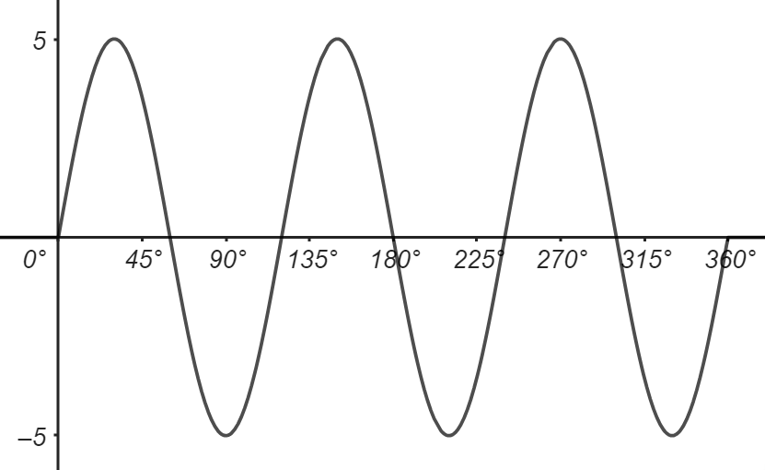

State the values of $a$ and $b$.

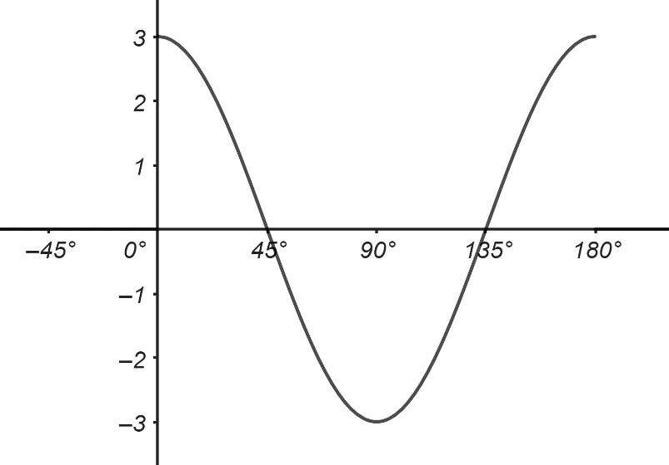
- Part of the graph of $y=a\cos{bx°}$ is shown in the diagram.
State the values of $a$ and $b$.
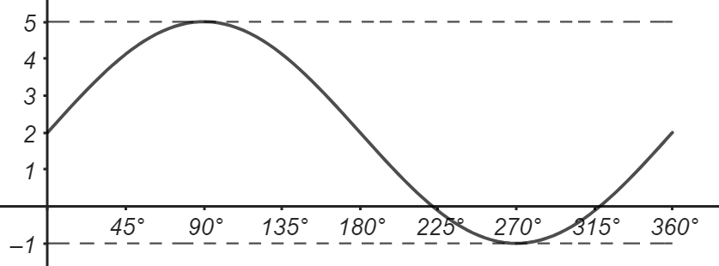
- Part of the graph of $y=a\sin{x°}+b$ is shown in the diagram.
State the values of $a$ and $b$.
- The graph of $y=a\sin\left(x-b\right)°$ is shown below for $0≤x≤360$.

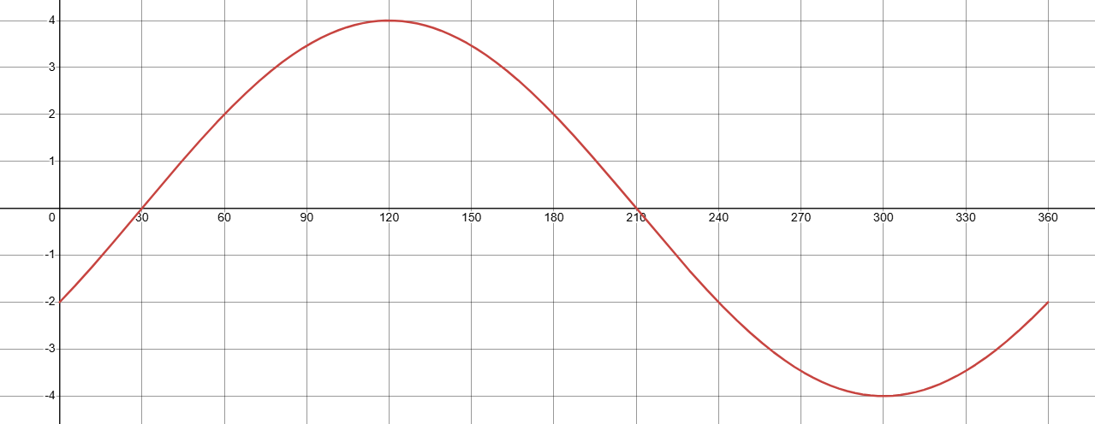
State the equation of the graph, and hence state the values of $a$ and $b$.

Simultaneous Equations (Non-calculator)

- Solve, algebraically, the system of equations:
$$3x-4y=11 \\ 2x+5y=15$$
- Solve, algebraically, the system of equations:
$$2p+5q=-4 \\ 4p+3q=6$$

- a) Whilst visiting a museum, a family buys 3 full price tickets and 4 concession tickets, costing £41 in total. Write down an equation to illustrate this information.

b) Another family buys 2 full price tickets and 5 concession tickets, costing £39 in total. Write down an equation to illustrate this information.
c) Betty’s family buy 4 full price tickets and 2 concession tickets.
Calculate, algebraically, the total cost of the tickets her family buys.
Area, Sine and Cosine Rules (Calculator)
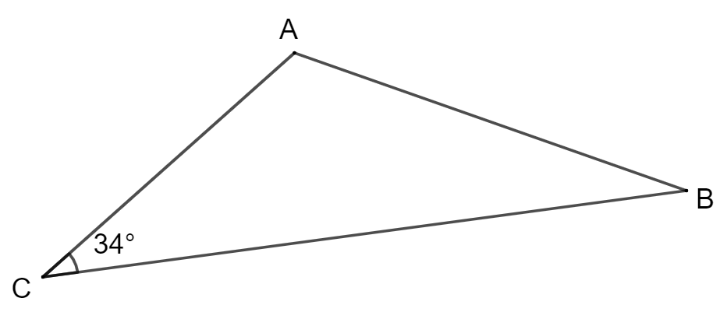
- Triangle $ABC$ is shown in the diagram below:
- Angle $ACB$ is $34°$
- AC is 4.5 metres
4.5 m
- BC is 9.2 metres
9.2 m

Calculate the area of triangle $ABC$.
Give your answer to three significant figures.

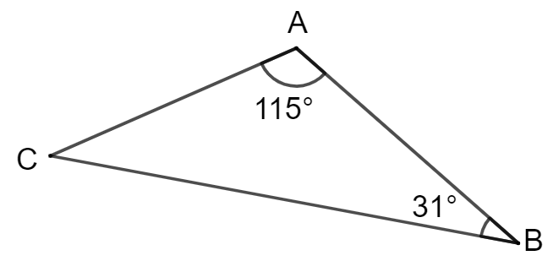
- Triangle $ABC$ is shown in the diagram below:
- Angle $BAC$ is $115°$
2.1 cm
- Angle $ABC$ is $31°$
- AC is 2.1 centimetres

Calculate the length BC.

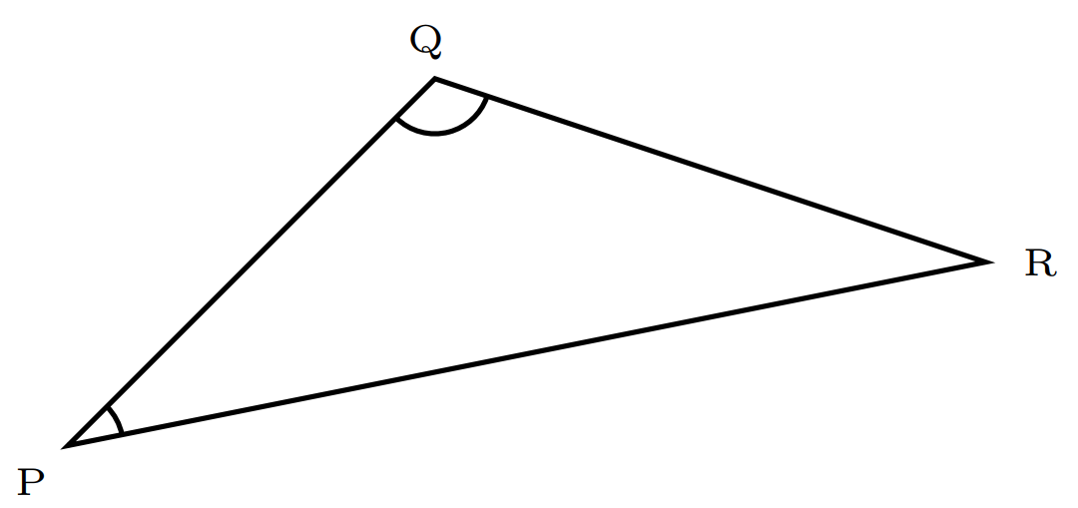
- Triangle $PQR$ is shown in the diagram below:
32 mm
- Angle $PQR$ is $117°$
$117°$
- $QR$ is 32 millimetres
- $PR$ is 51 millimetres
51 mm

Calculate the size of angle $QPR$.

- Triangle $ABC$ is shown in the diagram below:

- Angle $ACB$ is $34°$
- AC is 4.5 metres
4.5 m
- BC is 9.2 metres
9.2 m

Calculate the length of $AB$.
Give your answer to three significant figures.

- Triangle $PQR$ is shown in the diagram below:
17 cm
18 cm
- $QR$ is 18 centimetres
- $PR$ is 27 centimetres
- $PQ$ is 17 centimetres
27 cm

Calculate the size of angle $PQR$.

Algebraic Fractions (Non-calculator)

- Simplify: $\frac{x^{2}-25}{x^{2}+2x-15}$ .

- Express $\frac{x+3}{5}-\frac{x-2}{3}$ as a single fraction in its simplest form.

- Express $\frac{4}{x+3}+\frac{5}{x-2}$ as a single fraction in its simplest form.

- Express $\frac{4x^{2}}{3y}÷\frac{10x}{6y}$ in its simplest form.

Answers
Question | Answer | Question | Answer
1 | $$7400cm^{3}$$ | 26 | $\frac{26}{11}$ or $2\frac{4}{11}$
2 | $$3900cm^{3}$$ | 27 | $\frac{20}{9}$ or $2\frac{2}{9}$
3 | $$10.0cm$$ | 28 | $6\frac{13}{30}$ or $\frac{193}{30}$
4 | $3>x$ or $x<3$ | 29 | $\frac{15}{8}$ or $1\frac{7}{8}$
5 | $x<\frac{3}{2}$ or $\frac{3}{2}>x$ | 30 | $$6.56mm$$
6 | $x=\frac{13}{2}$ | 31 | $$8.37m$$
7 | $$x=3$$ | 32 | No, with justification
8 | $$10cm$$ | 33 | $$y=2x+8$$
9 | $$61°$$ | 34 | $y=-\frac{3}{2}x+11$
10 | $$34°$$ | 35 | $$(0,2)$$
11 | $$8.72×{10}^{10} miles$$ | 36 | $m=\frac{3}{2}$
12 | $$18$$ | 37 | $$W=10H+10, 250g$$
13 | $$6x^{2}+5x-3$$ | 38 | $$68$$
14 | $$x^{3}+2x^{2}-13x+10$$ | 39 | $$-2$$
15 | $$2x^{3}-5x^{2}-13x+4$$ | 40 | $$a=7$$
16 | $$-x+3$$ | 41 | $t=-\frac{4}{3}$
17 | $$x^{3}+6x^{2}+12x+8$$ | 42 | $$2(x+3)(x-3)$$
18 | $$x=6$$ | 43 | $$(3m+5)(3m-5)$$
19 | $$7500cm^{3}$$ | 44 | $$(x-4)(x-2)$$
20 | £14.40 | 45 | $$(y+5)(y-4)$$
21 | $$£344.61$$ | 46 | $$3(x+3)(x-1)$$
22 | $$£148 000$$ | 47 | $$(2x-1)(x-5)$$
23 | $$£10.75$$ | 48 | $$(3x+2)(2x-5)$$
24 | $$32$$ | 49 | median = $21$, IQR = $16$
25 | $$8,000$$ | 50 | mean = $17$, sd = $9.7$
Question | Answer | Question | Answer
51 | $$x=-2,x=5$$ | 68 | $$4$$
52 | $$x=-3,x=5$$ | 69 | $$a=5, b=3$$
53 | $$x=-\frac{1}{2},x=3$$ | 70 | $$a=3, b=2$$
54 | $$59.9cm$$ | 71 | $$a=3, b=2$$
55 | $$60.8°$$ | 72 | $$a=4, b=30$$
56 | $r=\frac{3P+k}{2}$ | 73 | $$x=5, y=1$$
57 | $$m=t^{2}+a^{2}$$ | 74 | $$p=3, q=-2$$
58 | $$k={\left(y-pr\right)}^{2}$$ | 75 | $$£38$$
59 | $$11\sqrt{3}$$ | 76 | $$11.6m^{2}$$
60 | $$19\sqrt{2}$$ | 77 | $$3.7cm$$
61 | $\frac{3\sqrt{35}}{7}$ | 78 | $$34.0°$$
62 | $\frac{2\sqrt{3}}{3}$ | 79 | $$6.02m$$
63 | $$2\sqrt{3}-6$$ | 80 | $$100.9°$$
64 | $6x^{2}$ | 81 | $\frac{x-5}{x-3}$
65 | $\frac{4}{x^{2}}$ | 82 | $\frac{-2x+19}{15}$
66 | $\frac{1}{p^{5}}$ | 83 | $\frac{9x+7}{(x+3)(x-2)}$
67 | $$\frac{9}{16}y^{10}$$ | 84 | $\frac{4x}{5}$

The purpose of this revision booklet
As a first step in your revision for the Prelim Exam, it is important to revise all the key skills you have met across the National 5 Maths course so far. This booklet aims to give you a chance to test your understanding of those key skills, so that you know when you are ready to begin working through either practice exam papers or past papers. You should use your notes and examples from class to help structure your solutions, asking for help with anything you don’t understand.

